Chapter 1 - Basic Computing Concepts
“File-clerk” model of computers:
- A computer shuffles numbers around - writing, reading, erasing, and rewriting different numbers in different locations according to a set of inputs, a set of rules, and a prior history of inputs - and then halts so that the output can be read by humans.
- Read - Modify - Write sequences of numbers
- All computers have at least 3 structures:
  - Storage - holds data
  - Arithmetic Logic Unit - performs operations on data
  - Bus - transports info between storage and ALU
- Basic machine instructions are - load data from RAM, perform operation, save result in RAM
- Relative addressing - instead of using the actual memory address to load/store data - if you know data will be stored in a memory array - you can find the memory address relative to the start of the array

Chapter 2 - Mechanics of Program Execution
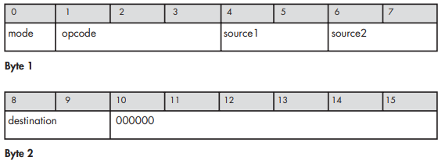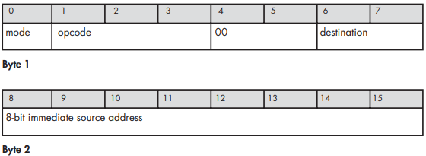
^^ Arithmetic Instruction Format, Memory Access Instruction Format ^^
- Opcode represents a particular instruction - i.e. add, store, load
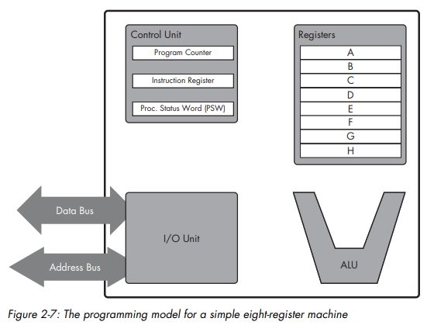
Programming Model
- Program counter - holds the index for the next instruction inside the program
- Instruction Register - holds the instruction being executed
Basic pattern for executing a program
- Fetch instruction from address in program counter and load it into the instruction register
- Decode the instruction in the register
- Execute the instruction
- Repeat
Clock pulse - clock generator on motherboard creates pulse - each instruction takes 1 pulse
Jump instructions
- Jump to parts of the assembly code based on the memory address
- PSW (Processor Status Word) - register that holds info about the last instruction for conditionals
Booting up - microprocessor is hard-wired to fetch the program to boot up from the RAM
- First program is the BIOS - at the end it jumps to the bootloader program which loads the operating system

Chapter 3 - Pipelined Execution
Most instructions are abstracted as:
- Fetch
- Decode
- Execute
- Write
Pipelined execution - instead of performing 1 instruction at a time, the CU will work on multiple instructions simultaneously like an assembly line
- The clock is now based on how much we slice the instructions
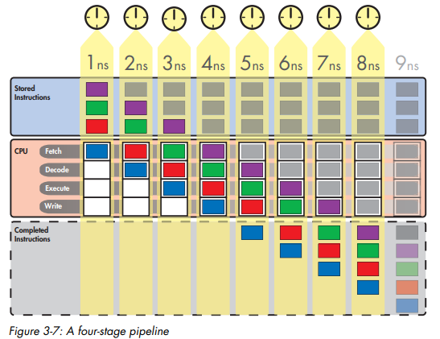
- Instruction throughput - instructions per clock cycle
  - Average vs maximum theoretical
- Pipeline stall
  - When instructions get stuck - creates bubbles in the pipeline where no instruction is being carried out
- Instruction latency - clock cycles for an instruction to pass through the pipeline
- Pipelining is only as fast as you can subdivide instructions, which has a limit because of physical limitations
- Clock cycles are now 1 per subdivision

Chapter 4 - Superscalar Execution
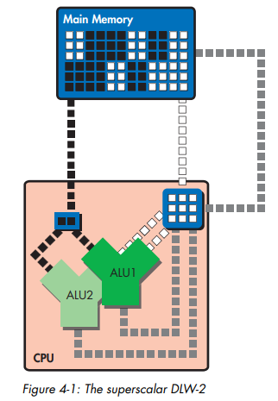
Superscalar execution - executing multiple instructions simultaneously
- Now, instructions have to be dispatched while being decoded
- Dispatch - determining if instructions can be executed simultaneously before being sent to separate ALUs
- Modern CPUs send instructions to multiple execution units, not just ALUs
Numbers & computer arithmetic
- 4 different number formats - scalars and vectors of either floating-point or integer
- 2 types of operations
  - Arithmetic - multiplication, addition, division, subtraction etc
  - Logical - AND, OR, XOR, NAND, etc
- Control unit is connected to multiple types of ALUs: Floating-Point Unit, Simple Integer Unit, Complex Integer Unit
  - LSU = Load Store Unit
  - BEU = Branch Execution Unit
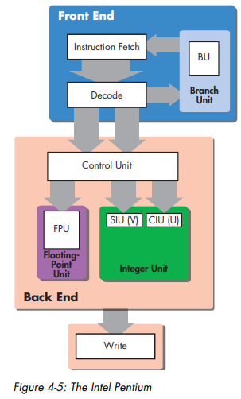
ISA (Instruction Set Architecture) - Abstraction built on microprocessor that allows for programs to be cross compatible across different CPUs
Hazards to dispatching
- Data Hazards
  - When the next instruction relies on data from the previous instruction, so they can’t be executed in tandem.
  - EX:
add A, B, C
add C, D, D
  - Forwarding - directly feeding the result into the input port, bypassing the write stage
  - Register renaming - temporarily using extra registers, before moving data back
- Structural Hazards
  - Multiple instructions require the same resource
  - Physical limitations mean that not every ALU can be connected to every register, so we have a register file, which is an array of registers w/ read/write ports
- Control Hazards
  - CPU is at conditional branch and needs to wait to see if the condition is fulfilled
  - Takes time to load the branch from storage - instruction load latency is added
  - Uses branch prediction to circumvent

Chapter 5 - The Intel Pentium and Pentium Pro

